**Python Data Type: Dictionary**

Name: Aleksandra Jaworska

Album no. : 162589

Group: WAW_2023_L_N_I_INF7_C4

Student email: [wwx19038@student.warszawa.merito.pl](mailto:wwx19038@student.warszawa.merito.pl)

GitHub link:

Structure of task presentation:

* The content of the task
* Theoretical issues
* Code
* Code result

1. Write a Python program to sort (ascending and descending) a dictionary by value.

def sum_list(items):

sum_numbers = 0

for x in items:

sum_numbers += x

return sum_numbers

print(sum_list([-1, 9, -8]))

OUTCOME:

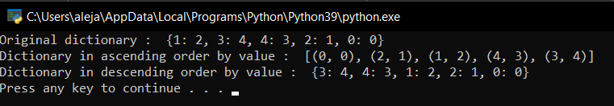

1. Write a Python script to add a key to a dictionary.

def sum_list(items):

sum_numbers = 0

for x in items:

sum_numbers += x

return sum_numbers

print(sum_list([-1, 9, -8]))

OUTCOME:

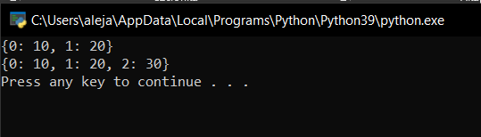

1. Write a Python script to check whether a given key already exists in a dictionary.

d = {1: 10, 2: 20, 3: 30, 4: 40, 5: 50, 6: 60}

def is_key_present(x):

if x in d:

print('Key is present in the dictionary')

else:

print('Key is not present in the dictionary')

is_key_present(5)

is_key_present(9)

OUTCOME:

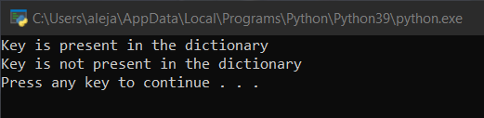

1. Write a Python program to iterate over dictionaries using for loops.

d = {'x': 10, 'y': 20, 'z': 30}

for dict_key, dict_value in d.items():

print(dict_key, '->', dict_value)

OUTCOME:

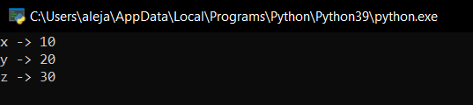

1. Write a Python script to merge two Python dictionaries.

d1 = {'a': 100, 'b': 200}

d2 = {'x': 300, 'y': 200}

d = d1.copy()

d.update(d2)

print(d)

OUTCOME:

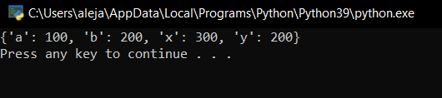

1. Write a Python program to iterate over dictionaries using for loops.

d = {'Red': 1, 'Green': 2, 'Blue': 3}

for color_key, value in d.items():

print(color_key, 'corresponds to ', d[color_key])

OUTCOME:

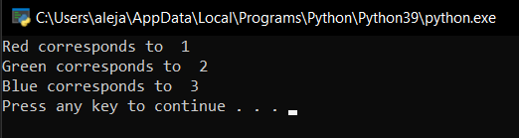

1. Write a Python program to sum all the items in a dictionary.

my_dict = {'data1': 100, 'data2': -54, 'data3': 247}

result = sum(my_dict.values())

print(result)

OUTCOME:

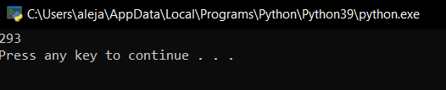

1. Write a Python program to multiply all the items in a dictionary.

my_dict = {'data1': 100, 'data2': -54, 'data3': 247}

result = 1

for key in my_dict:

result = result * my_dict[key]

print(result)

OUTCOME:

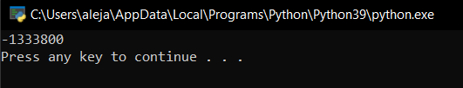

1. Write a Python program to remove a key from a dictionary.

myDict = {'a': 1, 'b': 2, 'c': 3, 'd': 4}

print(myDict)

if 'a' in myDict:

del myDict['a']

print(myDict)

OUTCOME:

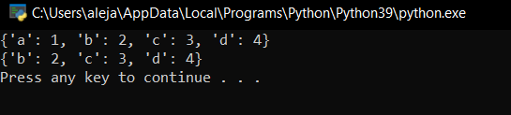

1. Write a Python program to map two lists into a dictionary

keys = ['red', 'green', 'blue']

values = ['#FF0000', '#008000', '#0000FF']

color_dictionary = dict(zip(keys, values))

print(color_dictionary)

OUTCOME:

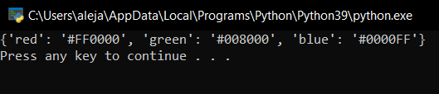

1. Write a Python program to sort a given dictionary by key.

color_dict = {

'red': '#FF0000',

'green': '#008000',

'black': '#000000',

'white': '#FFFFFF'

}

for key in sorted(color_dict):

print("%s: %s" % (key, color_dict[key]))

OUTCOME:

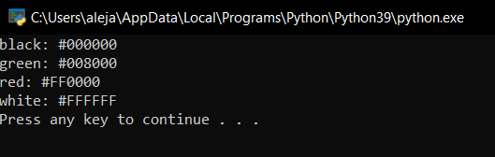

1. Write a Python program to get the maximum and minimum values of a dictionary.

color_dict = {

'red': '#FF0000',

'green': '#008000',

'black': '#000000',

'white': '#FFFFFF'

}

for key in sorted(color_dict):

print("%s: %s" % (key, color_dict[key]))

OUTCOME:

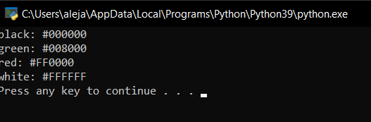

1. Write a Python program to get a dictionary from an object's fields.

class dictObj(object):

def __init__(self):

self.x = 'red'

self.y = 'Yellow'

self.z = 'Green'

def do_nothing(self):

pass

test = dictObj()

print(test.__dict__)

OUTCOME:

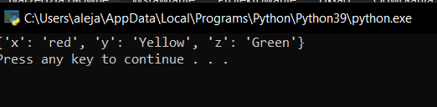

1. Write a Python program to check if a dictionary is empty or not.

my_dict = {}

if not bool(my_dict):

print("Dictionary is empty")

OUTCOME:

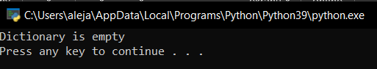

1. Write a Python program to create and display all combinations of letters, selecting each letter from a different key in a dictionary.

import itertools

d = {'1': ['a', 'b'], '2': ['c', 'd']}

for combo in itertools.product(*[d[k] for k in sorted(d.keys())]):

print(''.join(combo))

OUTCOME:

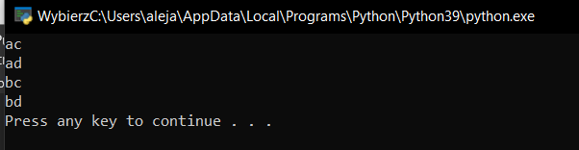

1. Write a Python program to find the highest 3 values of corresponding keys in a dictionary.

from heapq import nlargest

my_dict = {'a': 500, 'b': 5874, 'c': 560, 'd': 400, 'e': 5874, 'f': 20}

three_largest = nlargest(3, my_dict, key=my_dict.get)

print(three_largest)

OUTCOME:

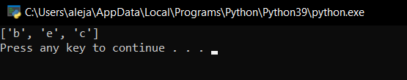

1. Write a Python program to print a dictionary in table format.

my_dict = {'C1': [1, 2, 3], 'C2': [5, 6, 7], 'C3': [9, 10, 11]}

for row in zip(*([key] + (value) for key, value in sorted(my_dict.items()))):

print(*row)

OUTCOME:

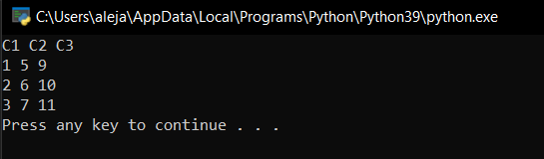

1. Write a Python program to convert a list into a nested dictionary of keys.

num_list = [1, 2, 3, 4]

new_dict = current = {}

for name in num_list:

current[name] = {}

current = current[name]

print(new_dict)

OUTCOME:

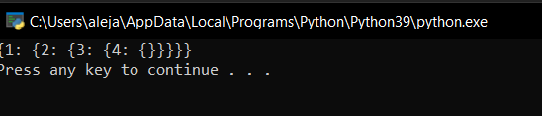

1. Write a Python program to sort a list alphabetically in a dictionary.

num = {'n1': [2, 3, 1], 'n2': [5, 1, 2], 'n3': [3, 2, 4]}

sorted_dict = {x: sorted(y) for x, y in num.items()}

print(sorted_dict)

OUTCOME:

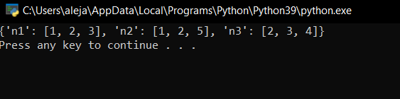

1. Write a Python program to replace dictionary values with their sums

def sum_math_v_vi_average(list_of_dicts):

for d in list_of_dicts:

n1 = d.pop('V')

n2 = d.pop('VI')

d['V+VI'] = (n1 + n2) / 2

return list_of_dicts

student_details = [

{'id': 1, 'subject': 'math', 'V': 70, 'VI': 82},

{'id': 2, 'subject': 'math', 'V': 73, 'VI': 74},

{'id': 3, 'subject': 'math', 'V': 75, 'VI': 86}

]

print(sum_math_v_vi_average(student_details))

OUTCOME:

